 | October Highlights
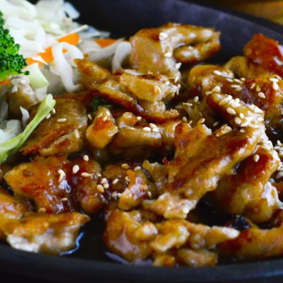  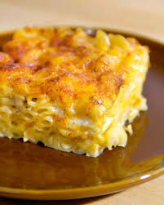  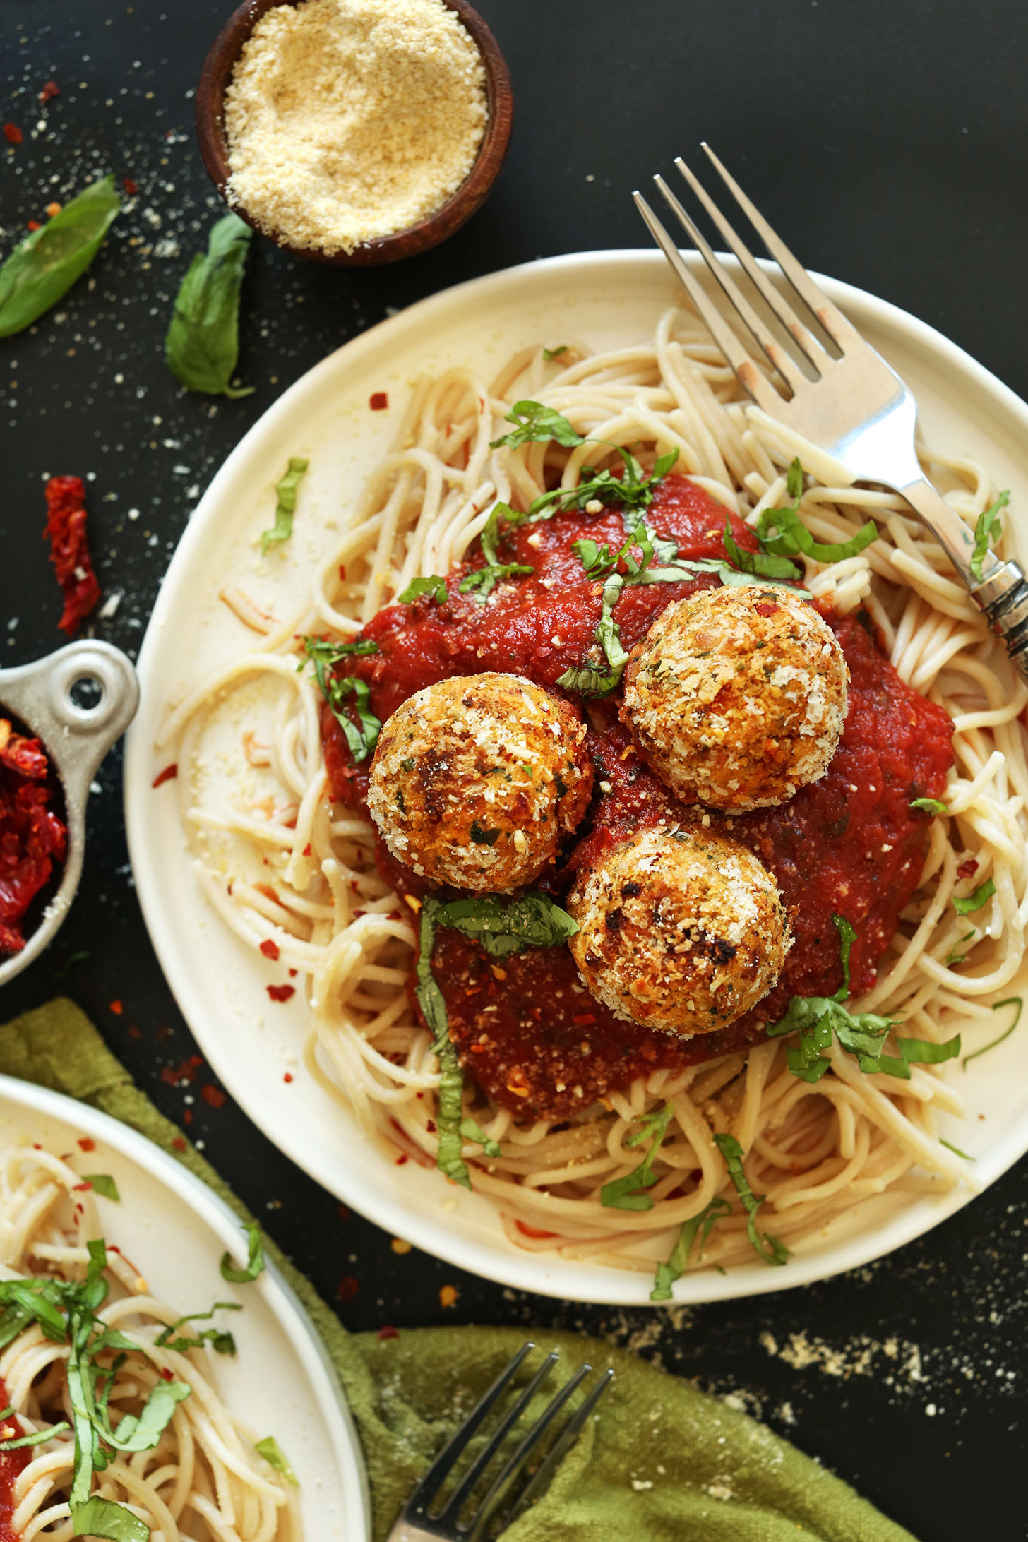  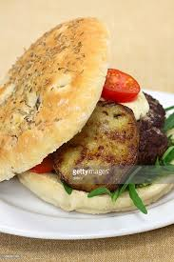 | Teriyaki Chicken  Teriyaki Chicken with a Bed of Whole Grain Rice, finished off with sautéed zucchini and a side of Pineapple for dessert. The Chinese Lunch Entree you were asking for... October 2  Bake Shop VI’s Baked Mac & Cheese  Don't miss out on BSVI's Baked Mac-n-Cheese with a side of stewed Tomatoes and a unique snack of "toasted" Chickpeas finishing with a Fresh Mango Salad. October 3  Meatballs & Pasta  Whole Grain Pasta with Marinara Sauce and Turkey Meatballs, Finished with a Layered Parfait of Gingersnap, Baked Apple and a kiss of Pumpkin and Greek Yogurt Whipped Topping. October 17  Juicy Beef Hamburger  A Juicy Beef Hamburger on BSVI's Own Whole Wheat Focaccia Bread, served with a side of Sweet Potato Fries and finish off with a twist on a seasonal treat, a "Pumpkin Pie Smoothie." October 22

